Linux Environment Variable Assignment

1. State the command for the following.
   1. view current environment variables

$printenv

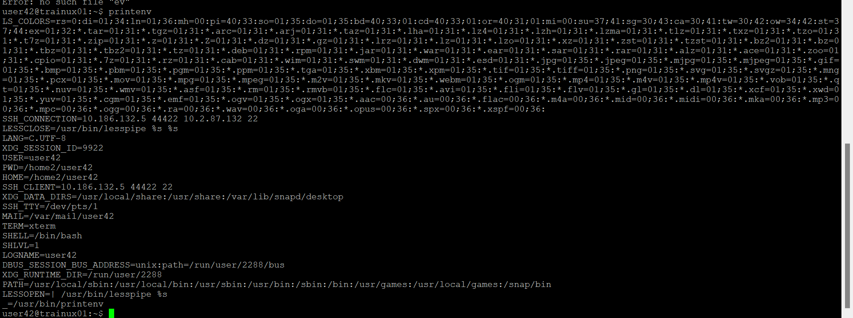

* 1. display the PATH evirnment variable value

echo $PATH



* 1. update PATH to include the path to your home directory

$export PATH=$PATH:$HOME

1. How will you make the environment changes applicable to all users? Which script is to be modified?

We need to modify the shell configuration file.The specific file depends on default shell used by the system

Edit the /etc/profile file.this file is executed for all user when they login

1. I have installed an application named “myapp”. After installation, if I invoke the application, it fails with error as “Command myapp not found”. How will you fix this?

Create the symbolic link:

a.Find the executable application:locate my app executable file

b.create symbolic link:use the command ( ln ) to create symbolic link to the iexecutable in the directory that is already in your path

ln -s /path/to/myapp/usr/local/bin/myapp